PRELIMINARY ANALYSIS REPORT
Refugee Survey: Language Barriers in Refugee Services
Kenya and Uganda | Data collected 25 July–1 August 2026
Updated KoboToolbox export: 1 August 2026
Draft prepared from the cleaned and standardised refugee-survey dataset
Research Code Academy – Working Group 6
Preliminary findings; not for population-level generalisation

Executive Summary
This report presents a preliminary descriptive analysis of seven responses to the multilingual refugee survey on language barriers in healthcare and legal/protection services. The analysis focuses on respondents’ communication experiences, perceived effects on service access and safety, current coping strategies, and preferences for interpretation and digital support.
- All seven respondents gave consent, reported being aged 18 or older, and had unique submission identifiers. However, the fields intended to confirm formal refugee status and previous use of health or legal services were blank for every record.
- Four respondents were based in Kakuma, two in another refugee-hosting area in Kenya, and one in Bidibidi, Uganda. Six respondents were from the Democratic Republic of the Congo and one from Burundi; six were male and one was female.
- Four of seven respondents directly reported having experienced communication difficulty when accessing healthcare or legal/protection services. Two had left a service without receiving help because of a language barrier.
- Three respondents said language barriers had made healthcare access difficult, while four felt a language barrier had put their health at risk. One respondent reported delaying or avoiding healthcare because of an expected language barrier.
- Three respondents said language barriers had made legal or protection services difficult to access. Five agreed or strongly agreed that language barriers affect access to legal/protection services.
- Family or community members were the most commonly reported communication strategy, used by four respondents. Incorrect translation was the leading interpretation concern, reported by four respondents, followed by disclosure of private information, reported by two.
- Four respondents had used a translation application with a service provider and reported that it worked well. Five were somewhat or very likely to use a free phone-based translation tool, and five preferred a voice-call format requiring no reading.
- Human support remained the dominant priority. More interpreters received the highest weighted priority score, followed by translated written materials and staff who speak the respondent’s language.
- Several internally inconsistent responses were identified and retained for transparency. These include selected challenges after a “no difficulty” response, contradictory phone-access responses, and simultaneous selection of a legal challenge and “no legal challenges.”
Interpretation of findings
Because the sample contains only seven non-randomly selected respondents, counts are the primary reporting unit. Percentages are provided only to support interpretation, and no result should be generalised to the wider refugee population.

1. Background and Purpose
The refugee survey was designed to examine how language differences influence access to essential services in refugee-hosting settings. It asked respondents about communication with healthcare and legal/protection providers, interpreter access, perceived risks, coping strategies, and the potential role of digital translation tools.
This preliminary report complements the separate service-provider analysis. It addresses five areas: respondent and language profile; general communication experiences; healthcare access and communication; legal/protection access and communication; and preferences for interpretation, digital tools, and service improvements.

2. Methodology

2.1 Data source and study sample
The analysis used the KoboToolbox labels and XML exports generated on 1 August 2026. Seven submissions were recorded between 25 July and 1 August 2026. The survey was available in English, Kiswahili, and French and included respondents in Kenya and Uganda.
All seven submissions met the recorded consent and age criteria, and no duplicate UUIDs were identified. Survey completion time ranged from 4.3 to 712.4 minutes, with a median of 20.9 minutes. The longest duration likely indicates that the form was left open or completed in more than one sitting; it was not treated as a reason for exclusion.

2.2 Data cleaning and quality control
Technical XML values were mapped to readable English labels, multilingual free-text language responses were preserved, and select-multiple questions were converted into response counts. The analysis did not silently alter internally inconsistent responses. Instead, seven contradiction flags were created and reviewed.
No record was excluded. Nevertheless, two important screening variables—formal status and previous use of healthcare or legal services—were blank for every respondent. All respondents still completed the healthcare and legal sections, so these findings are treated as self-reported experiences but cannot be linked to a verified screening response.

2.3 Analysis approach
The analysis was descriptive. Counts and percentages were calculated using the number of valid responses as the denominator. For select-multiple questions, respondents could select more than one option, so percentages may exceed 100% when summed. Ranked improvement options were scored using three points for a first choice, two points for a second choice, and one point for a third choice. No inferential statistical tests were performed because of the very small sample.

3. Results

3.1 Respondent profile
Characteristic | Distribution (n = 7)
Location | Kakuma: 4; other Kenya area: 2; Bidibidi: 1
Age | 18–24 years: 5; 25–34 years: 2
Gender | Male: 6; female: 1
Country of origin | Democratic Republic of the Congo: 6; Burundi: 1
Time in settlement | Less than 1 year: 1; 4–6 years: 3; 7+ years: 3
Education | Secondary: 5; vocational/technical: 2

Source: KoboToolbox Refugee Survey, updated export dated 1 August 2026 (n = 7).
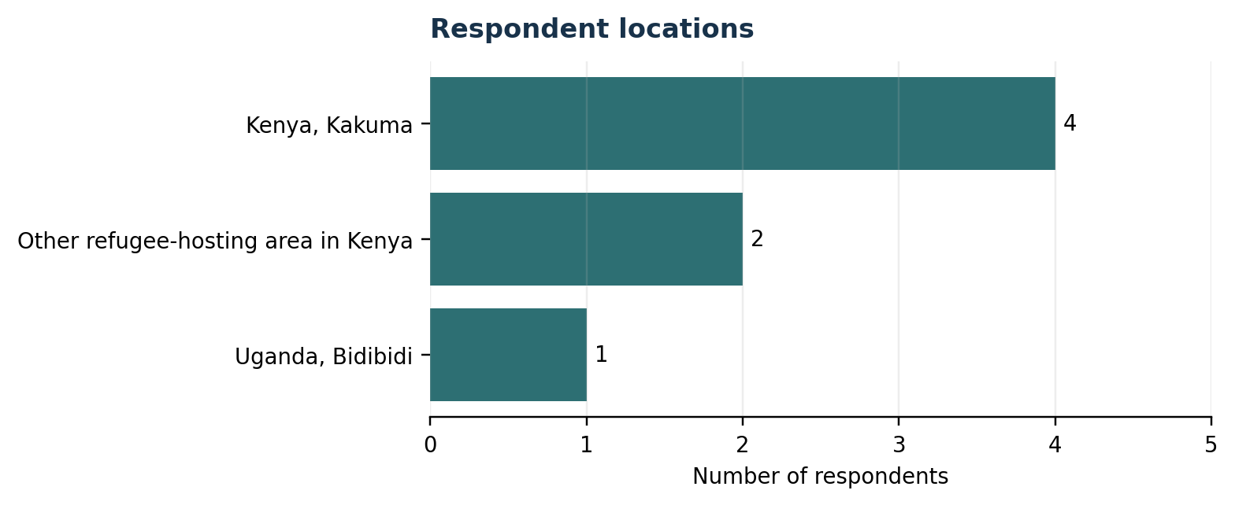
Figure 1. Respondent locations.
Source: KoboToolbox Refugee Survey, updated export dated 1 August 2026 (n = 7).
The sample was geographically concentrated in Kenya, particularly Kakuma. It was also predominantly young, male, and Congolese. These characteristics limit the diversity of perspectives represented in the findings.
Every respondent selected “Other” for the predefined primary-language options and entered a free-text response. The entries included Kiswahili, Lingala and Kiswahili, Kiswahili and English, Bembe, Kinande, and Kirundi. Five respondents also selected English as another language spoken, four selected French, three selected Swahili, and one selected Kinyarwanda.

3.2 General communication experiences
Most respondents rated their English-speaking and English-understanding ability as good or very good. Five usually communicated with service providers in Swahili, one in English, and one in French. Four respondents needed an interpreter at least sometimes: two sometimes, one often, and one always. The other three reported rarely or never needing one.
Overall communication was rated as easy or very easy by five respondents, while two rated it neither easy nor difficult. However, four respondents directly reported having experienced communication difficulties when accessing healthcare or legal/protection services, and two had left a service without receiving help because of a language barrier.
Indicator | Result
Experienced communication difficulty | 4 of 7 (57.1%)
Language barriers affected communication very often | 2 of 7 (28.6%)
Left a service without receiving help | 2 of 7 (28.6%)
Needed an interpreter sometimes/often/always | 4 of 7 (57.1%)
Satisfied or very satisfied with communication overall | 7 of 7 (100.0%)

Source: KoboToolbox Refugee Survey, updated export dated 1 August 2026 (n = 7).
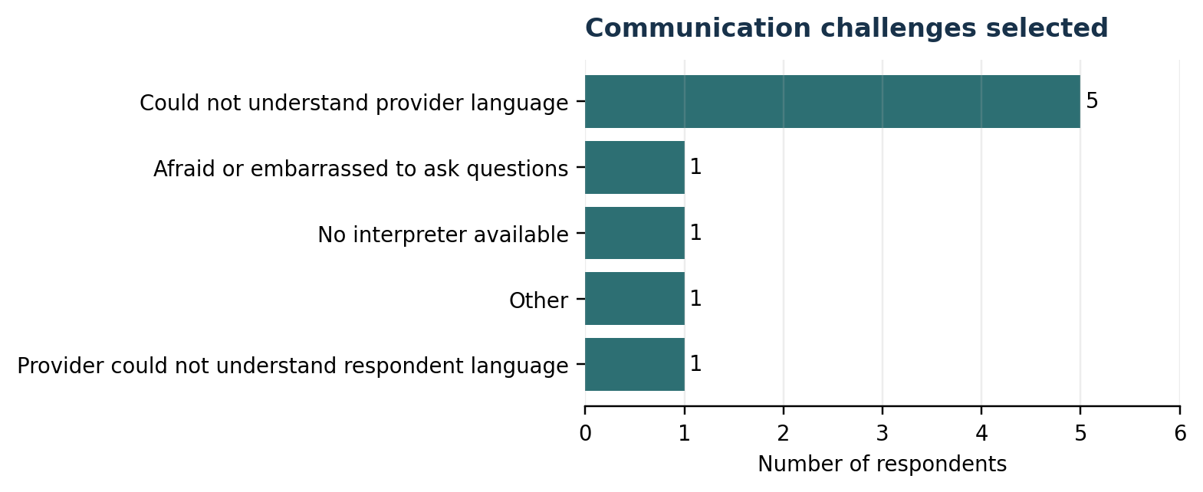
Figure 2. Communication challenges selected.
Source: Select-multiple challenge item; percentages may exceed 100%. KoboToolbox Refugee Survey (n = 7).
The checklist item produced a higher apparent level of difficulty than the direct yes/no question: five respondents selected that they could not understand the provider’s language. This item also contained contradictions for three respondents who had answered “No” to the direct difficulty question. It is therefore treated as exploratory evidence rather than a precise prevalence estimate.
When difficulties occurred, three respondents reported asking a family member or friend to interpret, two asked another refugee, one used gestures or body language, and one selected another response. Despite reported barriers, six respondents were satisfied and one was very satisfied with communication overall, suggesting that general satisfaction can coexist with specific difficult or risky encounters.

3.3 Healthcare access and communication
Healthcare indicator | Result
Language barriers made healthcare access difficult | 3 of 7 (42.9%)
Avoided or delayed healthcare due to expected language barrier | 1 of 7 (14.3%)
Interpreter never or rarely available during healthcare | 3 of 7 (42.9%)
Satisfied or very satisfied with healthcare communication | 5 of 7 (71.4%)
Felt a language barrier had put health at risk | 4 of 7 (57.1%)

Source: KoboToolbox Refugee Survey, updated export dated 1 August 2026 (n = 7).
Three respondents said language barriers had made healthcare access challenging. One had avoided or delayed care because a language barrier was expected, while four felt that a language barrier had put their health at risk. Interpreter access was inconsistent: two reported interpreters were never available, one rarely, two sometimes, one often, and one always.
The healthcare challenge checklist showed that two respondents had difficulty explaining symptoms and one had difficulty understanding the healthcare provider; four selected that they had not experienced healthcare communication challenges. Four respondents agreed or strongly agreed that language barriers delay healthcare access, while two disagreed and one was neutral.
Six respondents agreed or strongly agreed that they could communicate with healthcare providers. Five agreed that consent had been requested in a way they understood, while two disagreed or strongly disagreed. Four agreed or strongly agreed that interpreter services improve the healthcare experience; two were neutral and one disagreed.

3.4 Legal protection and legal aid
Legal/protection indicator | Result
Language barriers made legal/protection access difficult | 3 of 7 (42.9%)
Interpreter never available for legal/protection services | 2 of 7 (28.6%)
Satisfied or very satisfied with legal communication | 6 of 7 (85.7%)
Comfortable raising sensitive matters through an interpreter | 6 of 7 (85.7%)
Agreed language barriers affect legal/protection access | 5 of 7 (71.4%)

Source: KoboToolbox Refugee Survey, updated export dated 1 August 2026 (n = 7).
Three respondents directly reported that language barriers had made legal or protection services difficult to access. Interpreter availability varied: two reported never, two sometimes, two often, and one always. Six respondents were satisfied or very satisfied with communication during legal services, while one was dissatisfied.
Five respondents agreed or strongly agreed that language barriers affect their ability to obtain legal or protection services. At the same time, six agreed or strongly agreed that they could communicate effectively and understood the legal information provided. Five agreed or strongly agreed that interpreter services improve access to legal protection.
The legal challenge checklist must be interpreted cautiously. Three respondents selected difficulty explaining legal concerns, three selected difficulty understanding legal advice, and three selected no challenges. Two respondents selected both a specific challenge and “no legal challenges,” creating an internal inconsistency.
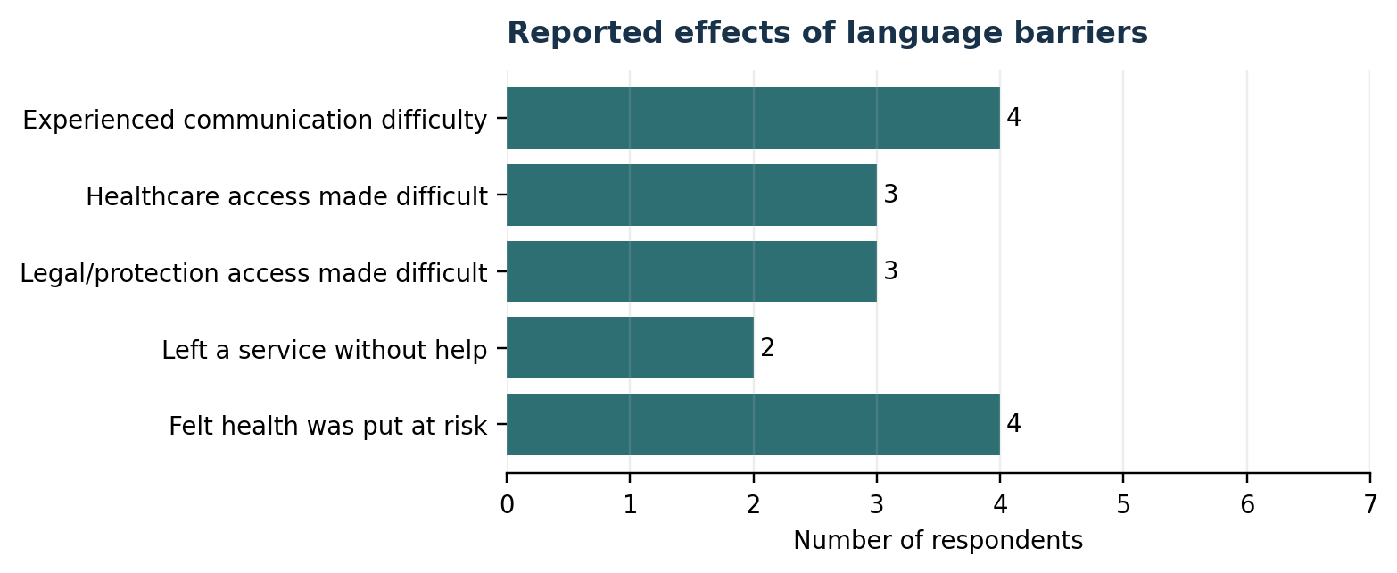
Figure 3. Selected reported effects of language barriers.
Source: KoboToolbox Refugee Survey, updated export dated 1 August 2026 (n = 7).

3.5 Communication strategies and digital readiness
Family or community members were the most common strategy used when a language barrier occurred, selected by four respondents. Gestures or body language were selected by two, two indicated that no strategy was available, and one selected bilingual staff. The strong reliance on informal support makes translation accuracy, confidentiality, and role boundaries particularly important.
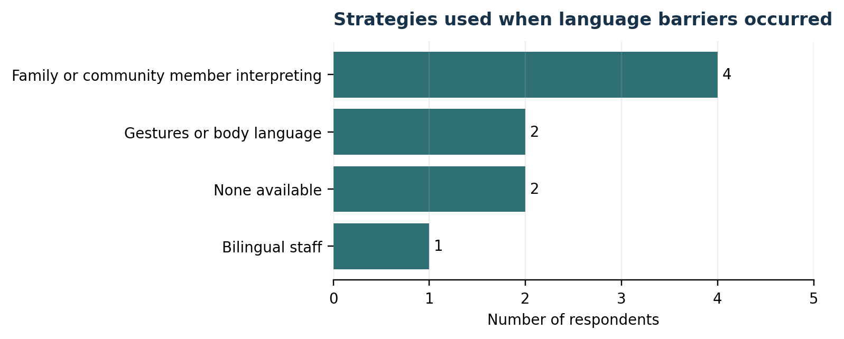
Figure 4. Strategies used when language barriers occurred.
Source: Select-multiple strategy item; percentages may exceed 100%. KoboToolbox Refugee Survey (n = 7).
All respondents reported access to a smartphone with Internet. Four accessed mobile Internet or Wi-Fi daily and three a few times a week. Nevertheless, three selected limited network connectivity as a barrier. Two also selected “I do not own a phone,” but these selections conflicted with their reported smartphone access and were not treated as confirmed evidence of phone ownership barriers.
Four respondents had previously used a translation application with a service provider and said it worked well. Five were somewhat or very likely to use a free phone-based translation tool and two were neutral. All respondents expressed at least moderate trust in machine translation: five trusted it moderately and two mostly.
Digital readiness indicator | Result
Smartphone with Internet access | 7 of 7 (100.0%)
Daily Internet or Wi-Fi access | 4 of 7 (57.1%)
Previously used a translation app successfully | 4 of 7 (57.1%)
Somewhat or very likely to use a free phone tool | 5 of 7 (71.4%)
Preferred voice call requiring no reading | 5 of 7 (71.4%)
Comfortable with voice recording | 5 of 7 (71.4%)

Source: KoboToolbox Refugee Survey, updated export dated 1 August 2026 (n = 7).
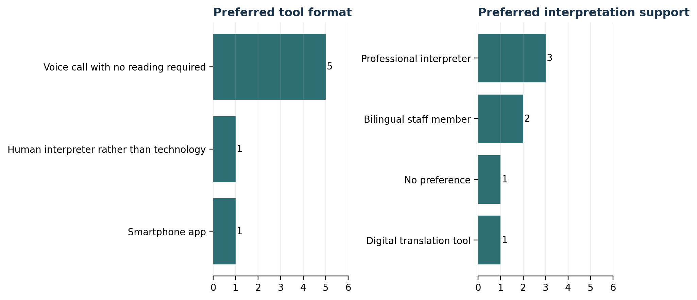
Figure 5. Preferred digital format and interpretation support.
Source: KoboToolbox Refugee Survey, updated export dated 1 August 2026 (n = 7).
A voice call requiring no reading was preferred by five respondents, compared with one smartphone-app preference and one preference for a human interpreter rather than technology. For interpretation support more broadly, three preferred a professional interpreter, two preferred bilingual staff, one preferred a digital translation tool, and one had no preference. These responses suggest that digital tools may be acceptable, but mainly as a complement to human support.
Incorrect translation was the leading concern, selected by four respondents. Two were most concerned about disclosure of private information and one about embarrassment. Five were comfortable with voice recording for translation, one was unsure, and one was not comfortable. Privacy, consent, and accuracy safeguards would therefore be essential in any pilot.

3.6 Priority improvements
Priority | Mentions | First choices | Weighted score
More interpreters available | 6 | 4 | 16
Translated written materials | 5 | 2 | 11
Staff who speak respondent language | 6 | 1 | 9
More time during appointments | 2 | 0 | 3
Other | 1 | 0 | 2
Translation apps or technology | 1 | 0 | 1

Source: Ranked-choice item. Weighting: first choice = 3 points; second = 2; third = 1 (n = 7).
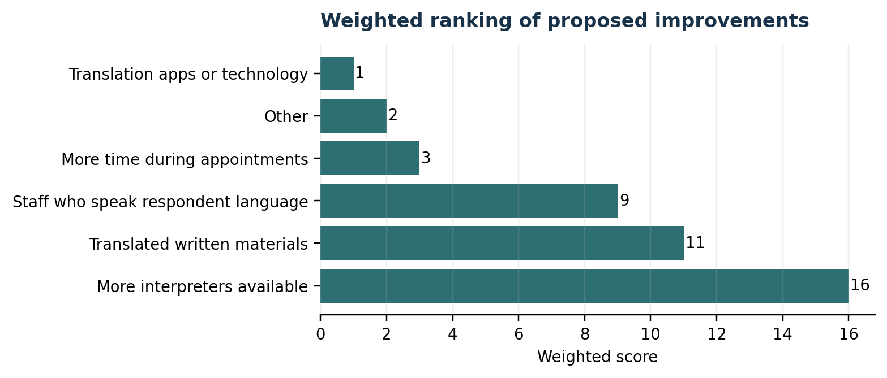
Figure 6. Weighted ranking of proposed improvements.
Source: Ranked-choice item. Weighting: first choice = 3 points; second = 2; third = 1 (n = 7).
More interpreters were mentioned by six respondents, ranked first by four, and achieved the highest weighted score of 16. Translated written materials ranked second with a score of 11, followed by staff who speak the respondent’s language with a score of 9. Translation applications or technology received only one third-choice mention. The ranking therefore places human and language-matched support ahead of technology as a stand-alone solution.

4. Discussion
The findings indicate that language barriers were not experienced uniformly, but they were consequential for a substantial share of the seven respondents. Four reported communication difficulty, two had left a service without help, and four felt language barriers had placed their health at risk. These outcomes matter even though overall satisfaction ratings were generally positive.
The coexistence of high satisfaction and specific negative experiences suggests that broad satisfaction measures can obscure critical moments. A respondent may be satisfied with a service overall while still experiencing misunderstanding, delayed access, inadequate consent communication, or risk during a particular encounter. The report therefore gives greater weight to concrete event-based questions than to a single overall satisfaction score.
Healthcare and legal findings show a similar pattern: three respondents directly reported access difficulty in each sector, while agreement statements indicated wider recognition that language barriers can delay healthcare and affect legal/protection access. However, contradictions in the legal checklist and missing screening information prevent precise conclusions about prevalence.
Human interpretation emerged as the strongest priority. Professional interpreters were most commonly preferred, family or community members were frequently used in practice, and more interpreters ranked first among proposed improvements. This gap between preferred and available support may expose respondents to accuracy and confidentiality risks.
Digital readiness was relatively high in this small sample. All respondents reported smartphones with Internet, four had successful prior experience with translation apps, and five were open to a free phone-based tool. The preference for a voice-call format suggests that usefulness, immediacy, and conversational access may matter more than a text-heavy application. Nevertheless, the low priority assigned to technology in the ranking indicates that it should support—not replace—professional or bilingual human assistance.

5. Preliminary Recommendations
The following recommendations are derived from the seven refugee-survey responses and should be refined after additional recruitment and integration with the service-provider findings.
- Expand access to trained professional interpreters. Develop interpreter rosters, rapid referral mechanisms, and priority pathways for health, consent, legal, protection, and other sensitive interactions.
- Increase language-matched staffing and multilingual materials. Map the languages used in each service area, recruit bilingual staff where feasible, and provide translated written or audio information in commonly used community languages.
- Develop a voice-first digital pilot as a complement to human interpretation. Test a low-cost phone or voice service for routine phrases, navigation, and basic information, with clear escalation to a trained human interpreter for complex or sensitive cases.
- Build accuracy, privacy, and consent safeguards into every communication option. Establish guidance on interpreter confidentiality, machine-translation limitations, voice recording, informed consent, data retention, and correction of mistranslations.
- Reduce reliance on untrained informal interpreters for sensitive cases. Where family or community members are used, staff should assess risk, obtain consent, verify understanding, and avoid informal interpretation when confidentiality or safety may be compromised.
- Address connectivity and usability constraints. Design digital tools for low-bandwidth conditions, support relevant local languages, provide simple interfaces, and include short user orientation or technical assistance.
- Improve the questionnaire before further data collection. Make status and service-use screening fields required, strengthen skip logic, prevent mutually exclusive options from being selected together, clarify phone-access questions, and correct misleading technical codes.
- Expand and diversify recruitment. Seek more women, respondents from additional countries and settlements, people with different language profiles, and participants with verified recent healthcare and legal/protection experiences.

6. Limitations
- The sample contained only seven respondents and was not randomly selected. Results cannot be generalised to all refugees or refugee-hosting areas.
- Four respondents were in Kakuma, two in another location in Kenya, and only one in Bidibidi. The sample therefore reflects a limited geographic distribution.
- Six respondents were male and one was female, limiting representation of women’s experiences.
- The formal-status and previous-service-use fields were blank for every record. The survey target group and direct exposure to each service could not be independently verified through these screening items.
- All respondents completed healthcare and legal sections despite missing screening information. Sector-specific results therefore require cautious interpretation.
- Seven internal contradiction flags were identified. These included challenge selections after a “no difficulty” response, contradictory phone-access responses, and mutually inconsistent legal challenge selections.
- The healthcare challenge item contained a technical XML code labelled “other” that corresponded to “I did not experience any challenges.” The readable label was used, but the coding issue should be corrected in the form.
- The survey relied on self-report and did not include interviews, observation, administrative records, or verification by service providers.
- One form remained open for approximately 712 minutes. Although retained, its duration is not a reliable measure of active completion time.
- Percentages can appear large in a seven-person sample. Counts should remain the primary unit of communication.

7. Conclusion
This preliminary analysis shows that language barriers affected access, understanding, and perceived safety for several of the seven refugee-survey respondents. The most serious reported outcomes included leaving a service without help and feeling that health had been placed at risk. Interpreter availability varied across healthcare and legal/protection encounters, while informal support remained common.
Respondents showed openness to digital support, especially a voice-based format, but their priorities clearly favoured more interpreters, translated materials, and staff who speak their language. A responsible response should therefore combine stronger human interpretation systems with carefully governed, low-bandwidth digital assistance.
The next stage should improve the questionnaire, collect a larger and more diverse sample, and integrate these findings with the service-provider evidence. Until then, the results should be presented as exploratory signals that help identify areas for further investigation and pilot design.

Appendix A. Core Frequency Summary

A1. Respondent profile
Response | Count | Percent
Kakuma, Kenya | 4 | 57.1%
Other refugee-hosting area in Kenya | 2 | 28.6%
Bidibidi, Uganda | 1 | 14.3%
Age 18–24 | 5 | 71.4%
Age 25–34 | 2 | 28.6%
Male | 6 | 85.7%
Female | 1 | 14.3%
DR Congo | 6 | 85.7%
Burundi | 1 | 14.3%

Source: KoboToolbox Refugee Survey, updated export dated 1 August 2026 (n = 7).

A2. General communication
Response | Count | Percent
Experienced communication difficulty | 4 | 57.1%
Did not experience communication difficulty | 3 | 42.9%
Needed interpreter sometimes/often/always | 4 | 57.1%
Usually used Swahili with providers | 5 | 71.4%
Left service without help | 2 | 28.6%
Satisfied/very satisfied overall | 7 | 100.0%

Source: KoboToolbox Refugee Survey, updated export dated 1 August 2026 (n = 7).

A3. Healthcare and legal/protection
Response | Count | Percent
Healthcare access made difficult | 3 | 42.9%
Delayed/avoided healthcare | 1 | 14.3%
Felt health put at risk | 4 | 57.1%
Healthcare interpreter never/rarely available | 3 | 42.9%
Legal/protection access made difficult | 3 | 42.9%
Legal interpreter never available | 2 | 28.6%

Source: KoboToolbox Refugee Survey, updated export dated 1 August 2026 (n = 7).

A4. Digital readiness and preferences
Response | Count | Percent
Smartphone with Internet | 7 | 100.0%
Daily Internet/Wi-Fi | 4 | 57.1%
Used translation app successfully | 4 | 57.1%
Likely/very likely to use free phone tool | 5 | 71.4%
Preferred voice call format | 5 | 71.4%
Preferred professional interpreter | 3 | 42.9%
Main concern: inaccurate translation | 4 | 57.1%

Source: KoboToolbox Refugee Survey, updated export dated 1 August 2026 (n = 7).

Appendix B. Data Quality Flags
Respondent | Flag | Details
1 | Reported no communication difficulty but selected at least one challenge | Could not understand provider language
1 | Selected 'no legal challenges' together with a specific legal challenge | Mutually inconsistent multiple-choice selections
2 | Reported no communication difficulty but selected at least one challenge | Could not understand provider language
2 | Selected 'no legal challenges' together with a specific legal challenge | Mutually inconsistent multiple-choice selections
4 | Reported smartphone access but also selected 'I do not own a phone' | Phone access response conflicts with digital-barrier response
5 | Reported smartphone access but also selected 'I do not own a phone' | Phone access response conflicts with digital-barrier response
6 | Reported no communication difficulty but selected at least one challenge | Other

Source: Automated consistency checks applied to the KoboToolbox XML export (n = 7).
End of preliminary report

